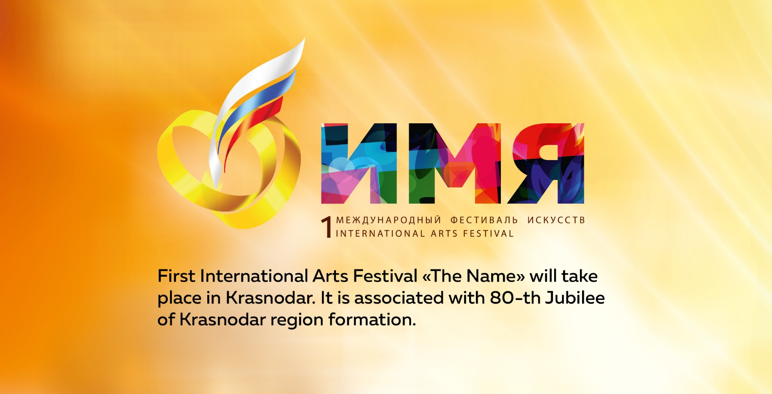первый Международный
вокальный конкурс «Имя». Он приурочен к 80-летию
Краснодарского края.
First International singing competition «The Name» will be held as part of First International Arts Festival «The Name» on 6, 7 and 8 October at Krasnodar Leonard Gatov Music Theater «Premiera». Festival will gather in the capital of the south of Russia an active creative youth and will enable the participants to show themselves in various musical directions. The contestants of the festival will be presented in four categories: pop vocal, folk vocal, jazz vocal, rock vocal.

MAIN TARGETS OF THE FESTIVAL:
— support of young talented musicians of various genres;
— boost of the professional level in realization of modern musical ideas;
— interchange of views and sharing experience;
— exchange of opinions and experience, mutual enrichment of various directions of modern youth musical culture.

"The Name" has all the prerequisites for reaching the international level, its goal is to attract the attention of youth circles of different countries to the Krasnodar region as a center of creative activity, a region of high culture. Festival "The Name" will put the main city of Kuban on a par with the recognized festival capitals of the world.

The implementation of this project is a true sign that modern youth culture is called upon by society and it has all the conditions for active and successful development.

The project is supported by the Ministry of Culture
of the Krasnodar region.

Preliminary selection round of the festival "The Name" starts on the 1-st of July and continues to 20-th of September, 2017. On October 6 and 7, the contestants will meet on stage in the semifinals, and the Final and Gala Show will take place on October, 8. Participants are expected to address a huge audience of the festival, and the luckiest of them will receive special awards and money prizes.
During the festival days, the semifinalists of the project will be able to attend master classes of famous musicians and cultural professionals.

The judging panel of the First International singing competition «The Name» consists of world musical celebrities. Among them – a soloist, author of the iconic group DE PHAZZ, legendary Karl Frierson and the teacher of the Berklee College of Music, the participant of the world tour with Stevie Wonder, Sting, Sher, a vocalist and percussionist - Vinx.

«Music is a universal language of communication and a democratic way of personal expression. «The Name» competition is a tool to discover and support talented musicians as well as to create a free artistic environment where every participant is granted a chance to show & express himself», said Alexander Glazunov, director of the First International Festival of Arts "Name".

The organizer of the festival is "Bureau of Active Marketing". The festival is supported by the Ministry of Culture of the Krasnodar region, the Anastasia Charitable Foundation and the Music Theater «Premiere». The general partners are the Almax construction company, the Paradise Beach health complex. The partner of the festival is "Krasnodarzovetsnab". General information partners - the radio station "DFM" and the TV channel "Kuban-24". Information partners - OzMall, Geometria, Mediatron, YugTimes, MassMedia Retail.
More information on the rules of participation in the festival and the schedule of events can be found on the website www.namefest.ru

